50th RDNA Anniversary Reunion
FAQ
Transportation, Maps, Lodging
At Carleton College, Northfield, Minnesota
January 23, 2013 Version 1.3

Part One: Transportation and Maps

see also Carleton College's excellent travel page at http://apps.carleton.edu/visitors/

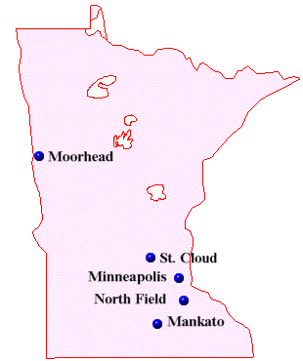
Getting to Minnesota

BY PLANE from anywhere in the world to Minneapolis

Minneapolis/St. Paul ("MSP" is the airport code for online searches) is a major hub for flights
.

BY BUS from anywhere in America to Minneapolis
Greyhound Bus Lines www.greyhound.com Information: 800-231-2222

Minneapolis Depot: 1100 Hawthorne Avenue (Also 1st Avenue)
To speak with an agent: 612-371-3325
St. Paul Depot: 166 West University Avenue
To speak with an agent: 651-222-0507

- Northfield Metro Express is the only bus line from Minneapolis to Northfield (see below)

BY TRAIN from anywhere in America to Minneapolis

Amtrak Passenger Services www.amtrak.com Information: 800-872-7245

Twin Cities Location: 730 Transfer Road, St. Paul 651-644-6012

Because trains to Minneapolis/St. Paul generally arrive late at night, you should plan to stay overnight at a hotel or motel near the station and then come to Northfield the following day by cab.

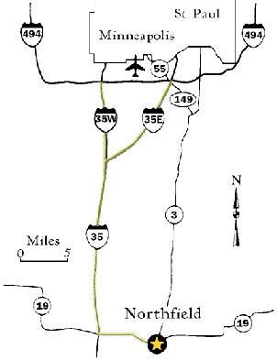
Getting from Minneapolis to Northfield

- You have four options to get from the Minneapolis/St. Paul Airport to Northfield (about 35 miles).
- You can rent a taxi ($60 one-way) ,
- renting a car, or
- take the Co-op Bus from the College during the school year, the more difficult Jefferson Bus (year-round), or
- take the free special Summer Alumni Chartered buses (June 19-22 and just say you are meeting your alumni friends in Northfield). See the details below.

Once in Northfield, you donft really need a car, as the area around Carleton is a very walkable place, and parking is a real hassle. Parking will be available at May Reunion (such as the Rec Center, early in the morning), but absolutely impossible at June Reunion (you'll have to park at a really distant place).

BY TAXI

From the airport to Northfield Minnesota is about $60 one way.

BY CAR from Airport to Northfield

- Take I-494 West to I-35W South to Highway 19 East (Exit 69, Northfield exit).
- Drive east on Highway 19 for 7 miles to Northfield.
- At the first stop light (where Highway 19 meets Highway 3), turn left and drive north for 3 blocks to 2nd Street.
- Turn right and drive east on 2nd Street, continuing up the hill.
- Turn left at College Street, which takes you directly into the campus.

BY BUS

  - Northfield Metro Express Website Phone (888) 748-9634
- Overview
The Northfield Metro Express features multiple route times, seven days a week with stops at Carleton College, St. Olaf College, Downtown Northfield, MSP International Airport, and the cities of St. Paul and Minneapolis. The motorcoaches are equipped with bike racks, restrooms, seat back tray tables, individual climate and lighting controls and free Wi-Fi.
- Cost
  - $12 each way if purchased in advance on line; $20 if purchased from the driver.
- How to Use
  - Call 888-748-9634 or visit the website to find a route that fits your need.
  - Pre-pay online by going to www.northfieldlines.com. Show the driver your boarding pass when entering the bus.
  - If paying cash: Put bills in the fare box. Pay exact fare. Change is not available.
  - Arrive 5 minutes early to board your bus. Metro Express buses run on time, do not be late! Buses will not wait for you, even if you have pre-paid the fare.
  - Listen for stop announcements and exit the bus at your stop.
- Schedule
  - Metro Express Schedule

BY JUNE SUMMER REUION AIRPORT SHUTTLE SERVICE

The luxurious motorcoach shuttle service is available for $35 round trip between the Minneapolis/St. Paul International Airport and Carleton College at specific times:

Remember to allow one hour for travel time between Carleton and the airport.

Pre-registration is necessary using the reunion registration form; if no one has registered in advance for a particular shuttle time, a shuttle will not be provided.

If you are arriving in St. Paul by train, you will need to take a taxi to the airport (approx. 30 min., depending on time of day).

When you arrive at the airport, proceed to the lower baggage claim level and check in at the Carleton information booth (look for signs and the maize yellow and blue balloons). Carleton students, dressed in reunion shirts, will assist you.

.

Getting around in Northfield
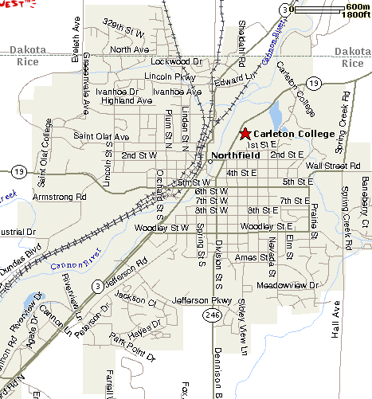

Northfield Taxi

Service is provided in Northfield and can make trips to the Twin Cities. Call the number below for rates and availability. Telephone Number 507-645-4447
.

Shuttle Services

Make your reservation directly with the company of your choice. Ask for an estimate of the fare.

You may want to connect with another person ahead of time and share the fare.

- First Choice Shuttle: Local, Twin Cities and Airport service - Call 507-645-4447 or 866-444-9696. Check out their Smart Ride Shuttle: $5 one-way ride anywhere within Northfield city limits.
- EcoTrans: Northfield to Twin Cities, Airport and Rochester service - Call 507-664-3859
- Top Notch Transportation: Northfield to Twin Cities, Airport and Rochester service - Call 612-600-8794

Getting around at Carleton

Walk, it's lovely.

No driving in the arboretum.

Good Carleton Campus Map
http://www.carleton.edu/visitors/maps/campus/CarletonCollege.gif

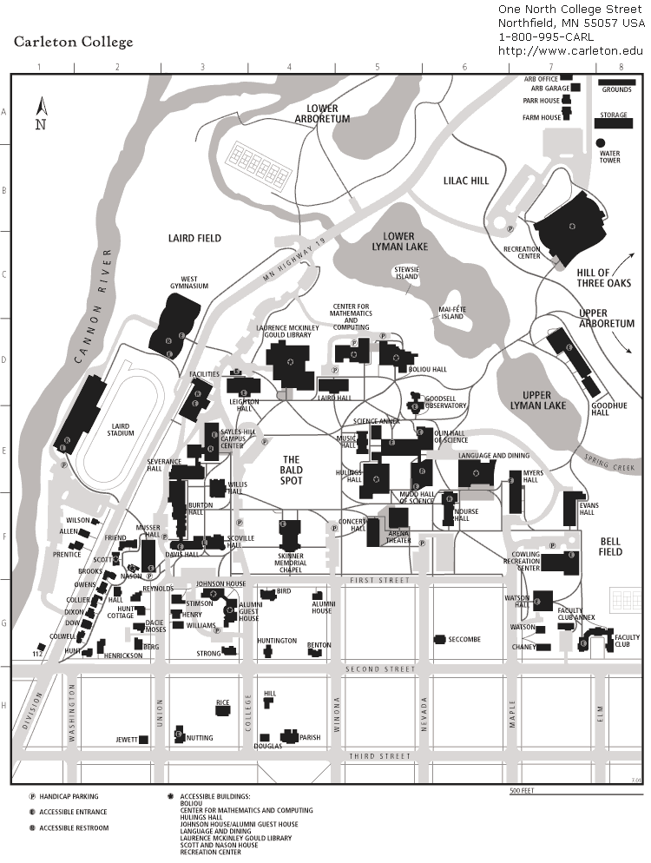
.

Getting around in the Arboretum

Carleton is one of the top five small liberal arts colleges (only 2000 undergraudate students), yet it is set in a sleepy college town of 14,000 people, with 800 acres of oak savana, flood plain forest, swamp, and prairie & upland forest with the scenic Cannon River running down the center with two lakes.

The Arb is used extensively as an outdoor classroom by a number of Carleton courses, particularly in Biology and Geology. The Arb has been a State Game Refuge for decades, and it serves a valuable role in providing habitat for species of diverse natural communities. As ecological restoration proceeds in the coming decades, the conservation value of the Arb will be substantially increased.

The most common recreational use of the Arb is by casual visitors who come to walk, run, ski, fish, or simply enjoy being outdoors. There are occasionally organized athletic events in the Arb, and both Carleton and St. Olaf teams use the Arb as a training facility for cross-country running and skiing.

Adjoining corn fields, golf courses and cemetaries greatly extend the green zone, and it therefore constitutes a major migration corridor for deer and waterfowl going north and south. It is rich with many mammals, reptiles and birds , much to the delight of the Druids.

Monument Hill was where the first service was held in 1963. It is important to find this for several of the Druid Events at both Reunions. Directions:To find it from the Hill of Three Oaks: face due south and leave the Hill and go to the paved road going and down a slope into the forest

(THe Druid's Den wooden gate will be on your left; right as you enter the trees, so don't enter Monument Hill's paved loop by mistake!), cross the first concrete bridge over an often non-existent brook, and staying on the paved road go up slope of the oak-savanah to a nice lookout bench facing Evans Hall (known as "Postage Stamp Prairie"), then go about40 yards fruther on the paved road and notice a dirt road on the left side of the path (east), take the rough wide dirt-rock path up for 60 yards, and you'll see the stone circle on the right (at the edge of the grassy fields). It's about 8 minutes on foot from the Hill of Three Oaks (nearly due south as the crow flies).

Much has changed in the Arb over 40 years, so walk around and note the transformation by Grounds crew!

Simple 800 Acre Official Arboretum Forest Map
http://apps.carleton.edu/campus/arb/assets/2012arbmapColor.pdf

Druidical Maps of the Arboretum

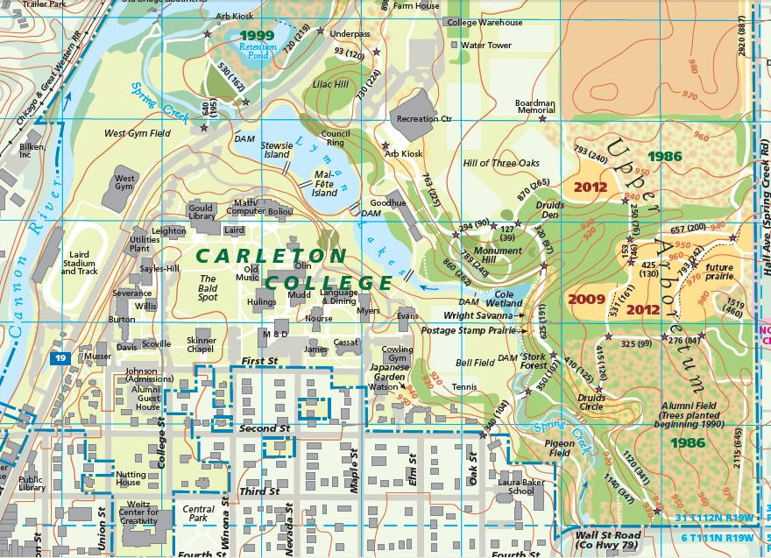
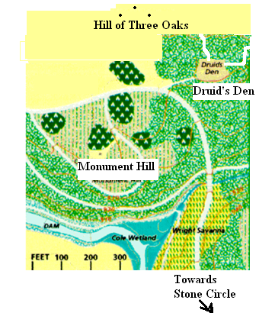
Most events will be taking place in the upper arboretum shown on the right side of the highway that divides the arboretum.
The Hill of Three Oaks (Firepit)
Monument Hill (no firepit) has a standing stone
Druid's Den (Firepit)
Stone Circle / Druid's Circle (no firepit) has a circle of 13 stones.
Handicap access to these sites, while difficult, is technically possible, but some assistance with hard and soft trails, some moderate inclines and varied maintenance, is recommended. Please inquire if any difficulties.

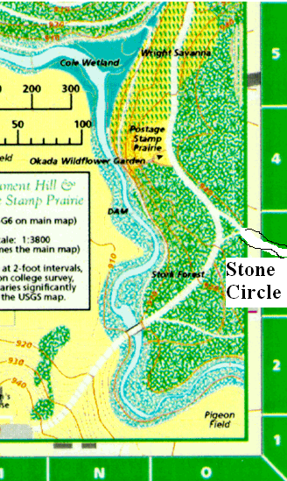
Besides these four location there are about a dozen other amazing spots, stone circles, megaliths, monuments, and striking areas of mystical significance throughout the 800 acres of the upper and lower arb.

We'll no doubt add walking tours of the arb onto the final schedule.

One in the day and one in the night.

Both islands in Lyman Lake are worth visiting.

- Stewsie island has a meditative labyrinth.
- Mai-Fete island was the historical site of May-Day festivities.

IF YOU GET LOST:

If you get lost, call or text one of the organizers of the reunion you are attending.

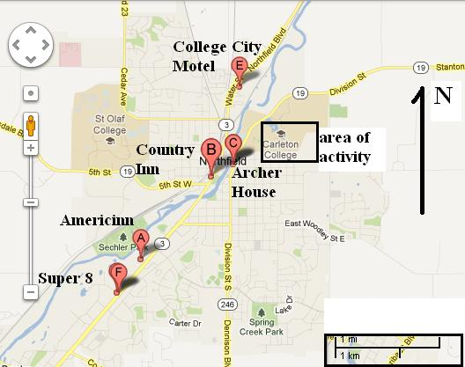
________________________________________
•Part Two:
Lodging & Accomodations

Northfield Hotels (use google to locate)

Everyone needs to find their own lodging (or surreptiously go camping) for the May celebration.

However, the June celebration offers Alumni & family a chance for real cheap on-campus lodging with meals. Non-alumni should reserve a hotel room, far in advance!!

Hotels

America's Best Value Inn & Suites
South Highway 3
Northfield, MN 55057
507-663-0371
888-315-2378
http://www.americasbestvalueinn.com

AmericInn Lodge & Suites
South Highway 3
Northfield, MN 55057
507-645-7761
http://www.americinn.com/

Archer House River Inn
(Closest but most expensive)
212 Division Street
Northfield, MN 55057
507-645-5661
800-247-2235
http://www.archerhouse.com/

College City Motel
875 North Highway 3
Northfield, MN 55057
(507) 645-4426
www.collegecitymotel.com

Country Inn & Suites by Carlson
300 South Highway 3
Northfield, MN 55057
507-645-2286
800-456-4000
http://www.countryinns.com/

Bed & Breakfast Inns And Suites

Archibald Inn Bed and Breakfast
107 First Street
Dundas, MN 55019
(507) 664-9481
http://www.archibaldinn.com/

Froggy Bottoms River Pub & Suites
309 South Water Street
Northfield, MN 55057
507-650-0039
http://www.froggybottoms.com

Historic Hutchinson House Bed & Breakfast
305 Second Street NW
Faribault, MN 55021
(507) 384-3291
http://www.historichutchhouse.com/

The Magic Door Bed & Breakfast
818 Division Street South
Northfield, MN 55057
507-581-0445
http://www.magicdoorbb.com/

Summer Reunion -on campus -Weekend Housing for Alumni in the dorms: http://apps.carleton.edu/alumni/

The Alumni website should be up by February.

